*Research Article*

**PREPARATION OF MANUSCRIPT**

**Author1 Firstname Surname3**+**, Author2 Firstname Surname2, Author Firstname Surname3**

1*Civil Engineering Department, Malawi University of Business and Applied Science, 312200, Malawi*

2*Author 2 Department, Author 2 organisation, Author 2 Postal code, Author 2 Country*

3*Author 3 Department, Author 3 organisation, Author 3 Postal code, Author 3 Country*

**Abstract**

An abstract with 250 words as the maximum will be required to give a clear indication of the objective (*by stating the purpose and motivation for doing the research*), methodology by giving (*a brief description of the research approach including methods that were used*), results (*by summarizing the main results of your study*), originality (*by* *making a clear and succinct case for the value of your results*) and conclusion (by *highlighting the main contributions of the research and show how they address a research gap*) to the body of knowledge so that readers may determine whether the full text will be of particular interest to them. Abbreviations and acronyms must be avoided, however, when they are used, they would need to be spelt out all on first use of the acronyms in the abstract and then in the text of the paper. The acronym will be put in parentheses immediately after the spelled-out term. Citing of references are not permitted in the abstract.

**Keywords**: Identify five words not appearing in the title of the paper separated by a comma {,}

+Corresponding author: author @gmail.com

1. **Introduction**

This is one of the most important sections of the paper. It will need to begin with a brief overview of the topic, followed by an explanation of the nature of the problem at hand and why it is critical to resolve the issue. This section will also include a review of the literature that provides relevant background information on the topic. The literature review will need to include seminal and ground-breaking works in the field, as well as the most recent studies relevant to your work. It will need also to conclude with a few lines describing the research gap in the domain of interest. This is where an explanation of why there has not been enough research on your chosen topic and make a case for more research. This is a convenient place to specify the research question or hypothesis. The final paragraph of the introduction will need to focus on the author’s work. There should be an explanation of how the paper intends to solve the problem and the approach after establishing the research gap should be introduced. A clear outline of the primary and secondary objectives of the paper should be highlighted. The section will need to conclude by explaining how the remainder of the paper is structured. Use word cloud diagrams to assist with the structure of research papers.

1. **Materials and Methods**

This section details information about implementation and will need to be written so that it can be replicated. It will also need to explain how the methods were validated and tested before they were used. Furthermore, this section will need to contain all technical information about the experimental setup, measurement procedure, and parameters of interest. Also, the scope of work, tools and data analysis techniques should be included in this section. It is suggested that equations, figures, and tables be used to explain the proposed method’s workings. Information about the sample size, population characteristics, interview process, and recruitment methods should be provided where data collection surveys are used. This section will need to conclude with a discussion of various statistical methods used for data analysis and significance testing.

1. **Results and Discussion**

Discussion section consists of three parts: addressing the hypothesis, problems and limitations. The purpose is to highlight the major findings from the results section and interpret them. Restate the overall purposes of the study in this section. Then, explain the main findings from the results section. Explain how the findings relate to the purpose of the study, considering each research question. Also describe how the results are related to education in general. Discussion section does not need to include any raw data, and statistics. Simply explain the results in language that is easy for a non-researcher to understand. Results and discussion section of the research paper will need to be the concluding part of the research paper. In the results section, authors can explain their experiments’ outcomes by presenting adequate scientific data to back up the conclusions. Authors must interpret the scientific data to readers by highlighting the key findings of the work. Authors also should provide information on any negative and unexpected findings that came out of the work. It is vital to present the data in an unbiased manner. Authors should also explain how the current results compare with previously published data from similar works in the literature. In the discussion section, the author will need to summarise the work and explain how the research work objectives were achieved. Authors will need to highlight the benefits of the work and what it would contribute to the overall scientific community and potential practical applications. Authors must not introduce any new information in this section not previously highlighted; the authors should only discuss things that have already been mentioned in the paper. The discussion section must talk about the authors’ works’ limitations; no scientific work is perfect, and some drawbacks are expected. If there are any inconclusive results in the work, authors should present theories about what might have caused them.

1. **Conclusions and Future Work**

In conclusion section, briefly summarize the overall conclusion of the data analysis based on the purposes of the study. Explain the important of the major findings to educational practice. Typically, in conclusion section the author should: summarize and conclude the results of analysis by restating the main argument, and presenting key conclusions and recommendation; state how the finding applies to the world of practice; state what are the implication for further research; say to what extend your original questions have been answered; and state the limitations of your research. Also, the plan should be outlined and an indication of how the additional research would benefit the research domain should be included.

1. **Guidelines on Preparing Manuscript**
2. **Equations**

Equations should be numbered consecutively beginning with (1) to the end of the paper, including any appendices. The number should be enclosed in parentheses and set flush right in the column on the same line as the equation. This number should be used when referring to equations within the text. Equations should be referenced within the text as “in (1).” When the reference to an equation begins a sentence, it should be spelt out, e.g., “Equation (*x*).”

1. **Acknowledgments**

Acknowledgments may be made to individuals or institutions not mentioned elsewhere in the work who have made an important contribution. Funder information, the name and grant number for each funding source will be included in a separate section of the paper. During the submission of the final files for publication authors will be asked to supply this information.

1. **Nomenclature**

The nomenclature list should be in alphabetical order (capital letters first, followed by lowercase letters), followed by any Greek symbols, with subscripts and superscripts last, identified with headings.

1. **Appendices**

The journal will support only supplemental material that is integral to the understanding and comprehension of the archival version of a research paper accepted for publication. If an author has supplemental material that they would like to submit for inclusion, they must receive pre-approval at the time of submission from the Editor and include it at the end of the main paper.

1. **References**

References within the text should be cited in alphabetical order according to their order of appearance. The reference style is numbered referencing style and numbered reference citations within text should be enclosed in square brackets.

Citation of authors

If there are two authors, cited paper should be written in this way (Joe & Mark

2001).

Cite papers with one author and two authors in this manner (Jim, 2021; Jack & Mayo, 2024).

Cite papers more than two authors in this manner (Gim et al., 2021.

Follow this format if you cite a secondary source (Suga & Madzi, 2021 as cited in

Msuzi, 2024).

Journal Publication

Agrida, K., Phaso, G. A. P., & Chimweye, X. P. (2024). How to write an article. Journal of Engineering Writing, Vol, 1, No 2, pp. 20–27. https://doi.org/10.1171j.Eng.2024.00700.

Reference to a journal publication with a DOI

Author, A. A., & Author, B. B. (Date of publication). Title of article. Title of Journal, volume number, page range. doi:0000000/000000000000 or http://dx.doi.org/11.0000/0000 Reference to a book:

Reference to a chapter in an edited book:

Kachru, B.B. (2006). Bamboo mechanical properties. In C.L. Baibo, P. Dzanja & A. Y. Gama (Eds.). The Complies of Alternative Building Materials (pp. 446-472). Dzuka Publishing.

Reference to a website:

A reference for a webpage lists the author’s last name and initials, the full date of publication, the title of the page (in italics), the website name (in plain text), and the URL.

Internet Source

Bojk A M., Mweli J & Koko A. (20204). Selected Southern African innovations: A Longitudinal study. Retrieved February 16, 2024 from http://sou.afr.ac.up/bojkp21.htm

Proceedings

Wongani, P. (2021). Harvesting water from air: A case study of Bunda. Conference Proceedings, 20-25 January, DEEG ISSN 1234-983321 (2021).

Reference to a conference paper

Author name, Initials. (Year, Month Day–Day). Paper title [Paper presentation]. Conference Name, City, State, Country. URL

Thesis or Dissertation

Ngoc Minh Vu. (2017). New ways of transporting electrical energy: Unpublished Ph.D Dissertation. Blantyre: School of Engineering, Malawi University Business and Applied Sciences.

1. **Figures and Tables**

All figures (graphs, line drawings, photographs, etc.) will need to be numbered consecutively and have a caption consisting of the figure number and a brief title or description of the figure at the bottom. Such a number will be used when referring to the figure in the text.

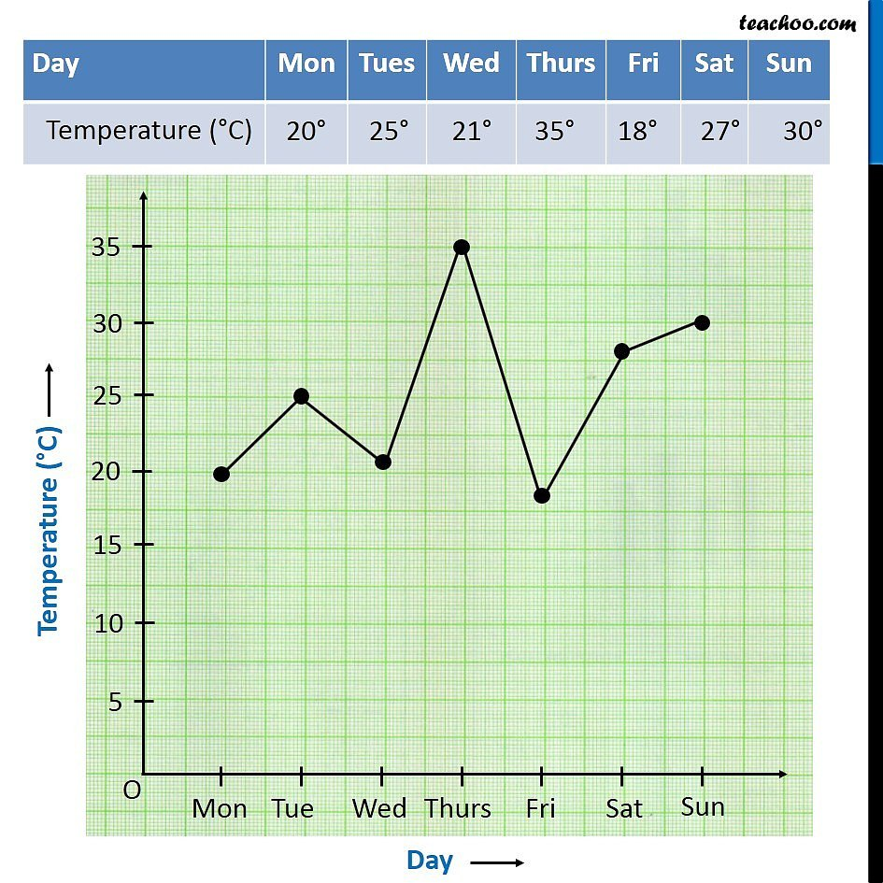

Fig. 1 Caption at the bottom

All tables will need to be numbered consecutively and have a caption consisting of the table number and a brief title at the top of the table.

Table 1 Caption at the top

|  |  |  |  |
| --- | --- | --- | --- |
| Heading | Heading | Heading | Heading |
|  |  |  |  |
|  |  |  |  |
|  |  |  |  |
|  |  |  |  |

This number will be used when referring to the table in the text. Table references will need to be included within the text in numerical order according to their order of appearance. The numbered reference citation within the text will need to be enclosed in square brackets.